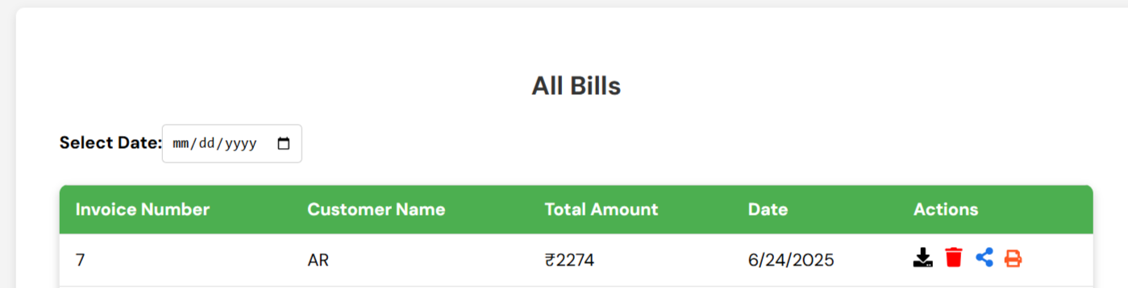

Invoice bill(remove all bills)

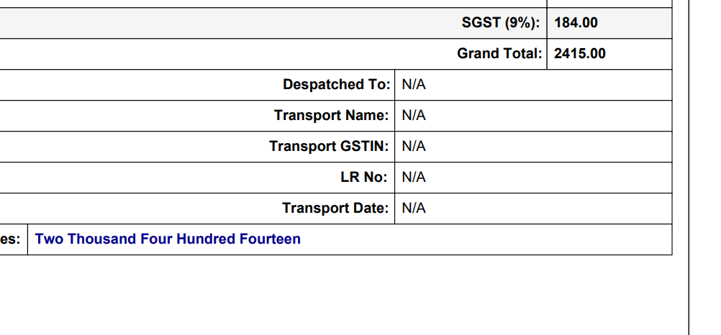
Transport Name
Dispatch From
Dispatch To
Remaining Remove

